Curriculum Conference Proposal 1
“Yes, you are a feminist dear.”
The Evolution of What It Means to be a Feminist
Sarah Pettus
University of Texas- Rio Grande Valley
Dr. Jewett

Abstract
The objective of this paper is to discuss the evolution of the term feminism from the suffrage movement through modern definitions using critical feminist theoretical framework. Analysis will attempt to answer primary questions: has the meaning behind the term feminist transformed? and how has the way feminism is portrayed changed as evidenced through its portrayal in media? The mode of inquiry includes an auto ethnography and textual analysis of the way feminism is represented in books or media. The paper will help curriculum writers & scholars recognize that while we all strive for diversity in education; the reality is we are aiming at a dynamic target and that large sections of women’s historical movement for equal rights have been excluded from current historical curriculum used in education.

Introduction
My spouse and I have both attended an openly feminist liberal college, Texas Woman’s University. While discussing a paper by Munro-Hendry “Engendered Curriculum Henry” a reading from Advanced Curriculum Studies, a course taught by Dr. Laura Jewett University of Texas Rio Grande Valley I had a bit of an epiphany about the varying meanings behind the word feminism. Our conversation went a bit like this:
Me: “Honey, can you believe I have a history degree from TWU and don’t know who Sybil Ludington is?”
Husband: “Yeah I am surprised we didn’t learn about her at TWU.”
Me: “Me too guess we aren’t very good feminists.”
Husband: <recoils in horror> “I’m not a feminist!!”
Me: <eye brow raised> “What?! Yes of course you are, don’t you think women should have equal rights?
Husband: “Well, of course I do.”
Me: <exasperated but, still baffled at his reply> “Then you’re a feminist dear.”
Husband: “I guess....” <husband still has a skeptical look on his face>

I couldn’t believe despite an equally liberal education and view point we had such different views of the term ‘feminist.’ This inspired me to begin to look at how this term has transformed in meaning and how it is portrayed through the hidden curriculum of media exposure.
Method
I examined changes in the meaning and portrayal or feminism using textual analysis as well as reflected on my own experience of the hidden curriculum of what is feminism. My analysis was framed using critical feminist framework. Newspapers, magazines, and advertisements were examined from the suffragette movement until modern history in the West spanning a period of approximately 150 years and all three waves of the feminist movement. I looked specifically at clothing of women in pictures depicting them as feminists, responses by non-feminists when contained within the pictures, body language including posture and facial expression of women depicting as feminists and others’ in the pictures corresponding posture and facial expressions as applicable. In addition text was examined for usage of italics, bold, font size, and font choice all of which have corresponding meaning placed upon their usage.
Data Sources
Two to three data sources from each of the three waves of feminism are included. In additional an image from the 1920’s as well as 1950’s is included as that time period is undefined within the waves of feminism. Data sources include post cards, newspaper and magazine advertisements, famous images, published cartoons, and photographs published online. Images were chosen from a variety of sources to allow for the greatest amount of variance between imagery. Data sources included can also be viewed in Appendix A through D.
Results
First Wave Images
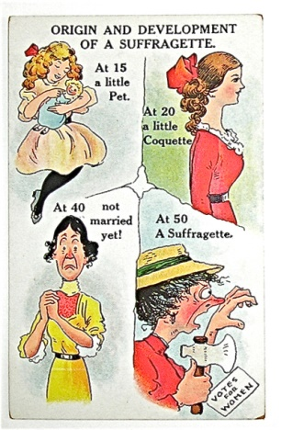 | 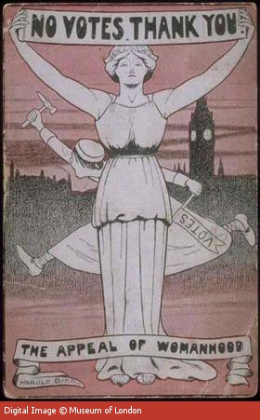
Images from the first wave of feminism equated feminism with the rejection of being feminine. In the post card, also found in Appendix A, where the “coquette” turns into a red faced suffragette who is not married and therefore eluded to as unhappy. The image also portrays the woman as beautiful who then morphs into red faced with a bulbous nose and unruly hair. This imagery was also used to describe teachers as ‘spinsters’ as they “contested the gendered nature of the discourses of social efficiency and progressivism (Munro-Hendry, 2011). The second image included from the period shows feminism in direct contrast to ‘real womanhood’ as such that the two could not co-exist. The text of the appeal to woman hood and not wanting votes in done in bold larger font while the votes appeal is written upside down and in smaller font further emphasizing the power of ‘woman hood’ over the call to feminism. This reflects what Grumet refers to as the “cult of motherhood” in which real women were expected to be quiet, submissive, and mother hood was seen as the pinnacle of the feminine experience (Pinar et. al, 2008).
Feminism outside of the traditional defining periods
1920’s 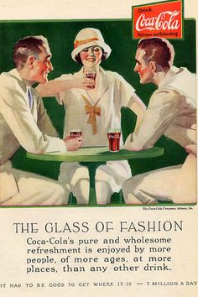 | 1940’s 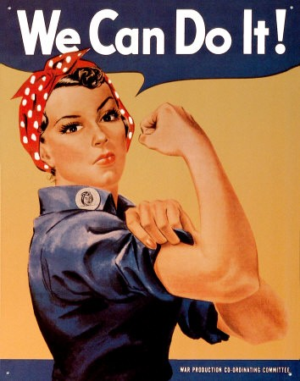
The period following the achievement of women’s suffrage and the inclusion of women in the workforce during WWII does not fit the parameters defining the three waves of femininsm (Rampton, 2015). The 1920’s era known in America, as the era of the Flapper provided a unique reflection on feminism as “the naught girl’s feminism” (Myrvang, 2015). Flappers were defined by their desire to step down from a pedestal of Victorian views of women hood as well as their unique mix of masculine and feminine fashion as a means to assert their power and challenge gender dynamics. In the Coca-Cola advertisement, also located in Appendix B, the flapper is depicted at equal height to the males in the picture eluding to her equality and yet, she is still in the background and almost dwarfed by the size of the males in the foreground who seem to be admiring her for what was considered then to be blatant sexuality as demonstrated by their red cheeks and her lipstick. Flappers were viewed by the public with equal parts admiration for fashion and disdain for their seemingly careless attitudes. “They’re like bad demons, hard as nails, smart as crooks, and they have the courage to live without morals or beliefs. No one can keep reins on them!” (Myrvang, 2015).
Another exception to the three waves of feminism existed for a brief time period during World War II as women entered the work force taking on jobs that had traditionally been seen as male roles. This lead to the emergence of a famous icon of femininity “Rosie the router” based on a real like women who worked in an aviation plant. Rosie is usually included in history text books but, given limited recognition instead when discussing WWII, text books emphasize military and political gain such as battles fought during World War II (Pinar et. al, 2008).
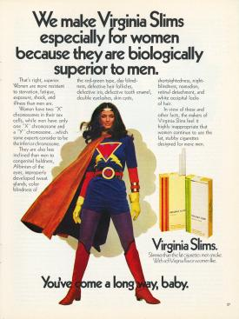 | 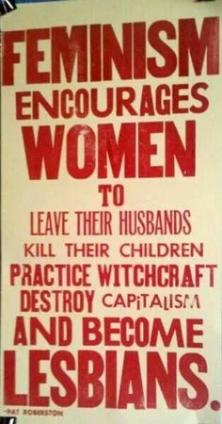
Second Wave Images
The second period of feminism is often referred to as the more radical period in feminism. The tobacco ad demonstrates in part why the period is seen as radical, as asserted not only were women equal but, they were superior to men. The ad depicts women as a heroine who ‘battles’ the injustice of gender inequality. This does not necessarily reflect acceptance of feminism so much as the growing awareness of consumer markets of the power of women in making consumer based purchase decisions.
Many equate this time period with burning of bras, not shaving, and total rejection of feminism. Conservative leaders of the time period condemned feminism and used posters such as the one depicted above. The message presents one of feminism as dangerous and not compatible with society. The font choice of Feminism encourages women to be much larger is meant to draw in even those supporters of feminism to read. The differing fonts chosen with the poster signify the anti-society and reason the poster is stating feminism stands for. The assertion in the poster than feminism would lead to lesbianism reflects fears of the time as well as the philosophical split during the 1970’s between heterosexual and lesbian feminists “over the definition of what it meant to be a woman” (Pinar et. al, 2008). While traditional views over the second wave claim it ends in the late 1970’s (Ramport, 2015) this ignores the Supreme Court decision that rape does exist in marriage in 1983 that I propose was a culmination of the efforts of the feminists of the second wave.

Third Wave Images
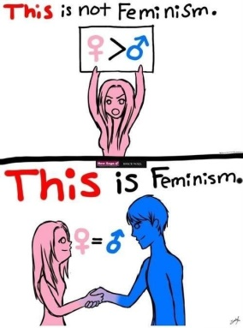 | 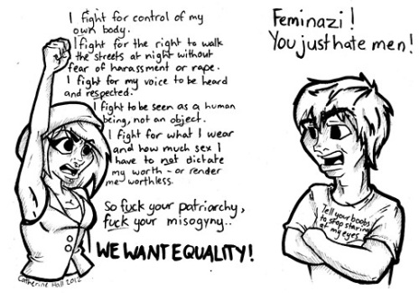 | 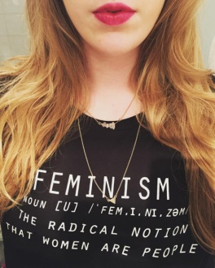
This is the period that as an auto ethnographer I can speak most accurately on as I came into adult hood at the turn of the 21st century. Feminism for me has always meant the belief that men and women are equals and so I viewed most men and women in this light, as feminists. I had not been exposed to the ‘radicalism’ of rejection of femininity or the belief that women were superior and so equated those more with a dying version of women’s lib. This was furthered by my hidden curricular exposure to my mother, who while employed in a traditionally feminine field of nursing broke through “glass ceilings” and spent the majority of her career in high level administrative positions such as CEO and COO of a variety of companies. This was also further compounded and confused by media such as “My Big Fat Greek Wedding” which explained the gender roles as “the man is the head and the woman is the neck, she turns him where ever she wants him to go.” The image on the left shows men and women as equals and eliminates some of the radical beliefs from the 1970’s. This image viewed alone would present us in a truly enlightened era however, the image in the middle shows a young women dressed provocatively explaining what she is fighting for to a male with a shirt on that sexually objectifies women. I find that our reality is somewhere between those two images.
Happily, I have been exposed through deliberate ‘profeminist’ literature and instructors (Pinar et. al, 2008) which, has allowed for my own vision of feminism much like the third image shown. This image which purposely shows a woman in feminine clothes and wearing lipstick speaks to the “lipstick feminism” movement which incorporates the struggle of the second image with the ideals of the first and the brash refusal to view being feminine as a weakness. This view of femininity as power dates back to a century ago with the Flappers (Myrvang, 2015). However, as the three images depict the modern idea of what is a feminist is still evolving and will continue to do so as well as the need to stop seeing the sexes as “opposite players in some... unwinnable game rather than as allies seeking to solve” the same problem as gender inequality harms both the sexes (Bettis & Adams, 2011).
The textual analysis over the three waves as well as the two time periods excluded from those traditional definitions showed a huge transformation from what women ourselves viewed as feminism (Pinar et. al, 2008) as well as the societal view of feminist as weak and crazy in the suffragette period, to strong and independent in the 1920’s and 1950’s, culminating in dangerous and powerful in the 1970’s-1980’s, and finally with the modern emergence of “lipstick” feminism as simply being a struggle for equality for the genders. As we have all been repeatedly exposed to advertisements and imagery in media we have been immersed in this lived and often hidden curriculum which, defines how the genders interact and view each other. During this analysis as textual and auto ethnographic I discovered that my personal definition befits closer to my own hidden curriculum exposure of modern images and definitions while, my husband had previously equated the term with the more radical views of the 1970’s due to his own hidden curricular exposure to the term feminist.

Scholarly Significance of Work
The ever changing view of feminism reflects the challenges faced by modern curriculum writers and scholars who seek to be inclusive and provide texts to students that showcase women’s influence in history. While arguably pro-feminist instructors are needed to address both the hidden and overt practices within education (Pinar et. al, 2008) curriculum in text and lived curriculum should also be examined for pathways to inclusion and greater equity. Most textbooks include only the suffragette period when discussing the 150 year continued struggle for gender quality (Williams, 2011). Yet, despite recommendations by the American Textbook Council to cease use of those biased texts (Williams, 2011) high school history curriculum continues to be largely based on those textbooks as a singular view of history thus excluding major periods of importance in the struggle for gender equality. While we may not be able to fully address the lived curriculum and hidden curriculum surrounding feminism in the media we can and should address it within historical texts presented at the high school and collegiate level. In addition due to lack of education of the second and third wave of feminism much ignorance prevails on what it means to be a feminist for both men and women. This ignorance due to curriculum deficits results not only in a silencing of women’s voices but, a “poisonous” educational environment that ignores the struggle for gender equality within historical texts (Bettis & Adams, 2011).

References
Bettis, P. & Adams, N. (2011). Troubling boys and alpha girls: Worries over gender and
schooling. In S. Tozer, B.P Gallegos, A.M Henry, M. Bushnell Greiner, & P. Groves Price, (Eds.). Handbook of research in the Social Foundations of Education. New York: Routledge.
Munro-Hendry, P. (2011). Engendering curriculum history. New. York: Routledge.
Myrvang, C. (2008). How flappers rebelled through feminism and consumerism. Business
Review. Retrieved from http://www.bi.edu/bizreview/articles/how-flappers-rebelled-through-feminism-and-consumerism/
Pinar, W.F., Reynolds, W.M., Slattery, P., & Taubman, P.M. (2008). Understanding
Curriculum. New York: Peter Lang. p.358-376
Rampton, M. (2015, October 25). Four Waves of Feminism. Retrieved July 02, 2016, from
http://www.pacificu.edu/about-us/news-events/four-waves-feminism
Williams, F. J., & Bennett, L. B. (2016). The Progressive Era: How American History
Textbooks' Visuals Represent Women. Social Studies Research & Practice,11(1).

Appendix A
Images from the 1st wave of feminism
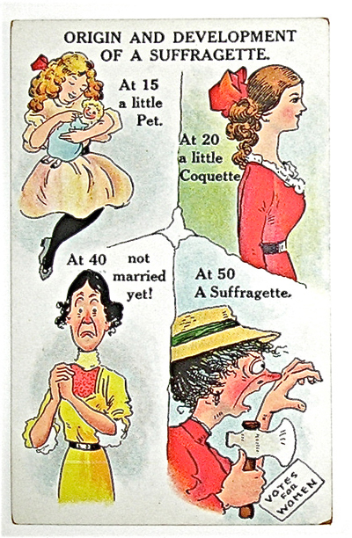
Image from: https://thesuffragepostcardproject.omeka.net/items/show/163
from: http://www.20thcenturylondon.org.uk/mol-50-82-851

Appendix B
Images of feminism from 1920’s and 1950’s

Image from http://www.vintageadbrowser.com/drinks-ads-1920s/5
Image from http://www.shorpy.com/node/16433
Appendix C
Images from second wave of feminism
Image from http://gender.stanford.edu/news/2012/stanford-researchers%E2%80%99-cigarette-ad-collection-reveals-how-big-tobacco-targets-women-and
Image from https://www.pinterest.com/noamiller/feminism/
Appendix D
Images from third wave of feminism
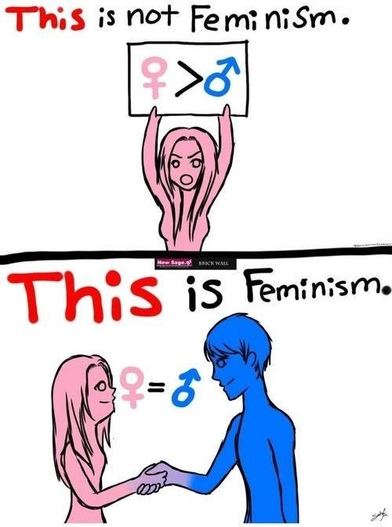
Image from: http://www.hercampus.com/school/uprm/feminism-dummies
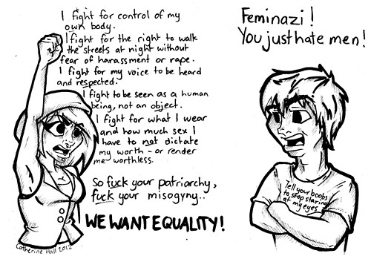
Image from: http://www.welcometomybrainn.com/

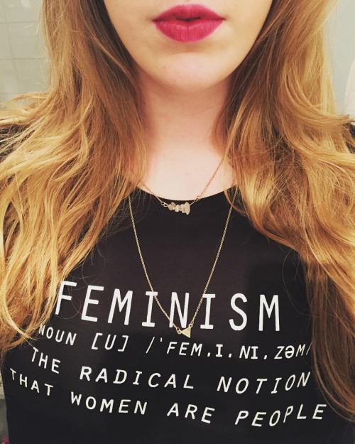
Image from: https://41.media.tumblr.com/955cb5931f638b078e3162fe68600da2/tumblr_nzu3w3Zyvb1qbavw1o1_500.jpg

