Sarita Pettus
Cooperative Learning Lesson Plan
Subject Area: Learning Frameworks EDUC 1300
Lesson Topic: Critical Thinking presented using Jig-saw method of cooperative learning
Group size and how they will be picked: 2 *one group will have 3 members due to odd numbers of students. Students will each chose a card from the specially counted deck of cards. They will group according the number they get. The number card also determines their topic.
Assignment to groups: Students will each be assigned a portion of the chapter from the text to read and analyze. They will have 15 minutes to prepare a 2-3 minute overview presentation of the material with a few “real” world example. They will then present to class. Students will be taught about appropriate communication in groups with a T chart of what is appropriate and what is not. As I hear a group using appropriate communication I will write their names on a sticky note and put it on the T chart.
Materials:
- Learning Frameworks Text: Cornerstones for College Success 7th edition
- Deck of cards sorted in A-10 in 2 suites with an additional number 7
- markers
- power point introduction and guideline
- t- chart
- sticky notes
Academic Skill: Learn multiple parts of critical thinking and apply those skills to a magazine article.

II. Set the Lesson
Academic Task: Design a 2-3 minute presentation for you peers to introduce a topic in the chapter and include a real world example.
Criteria for Success: Students work together for the entire 15 minute period to read, summarize, and to prepare a presentation for the class. They will also have to come up with real world examples.
Positive Interdependence: Students will receive one score for their presentations. Students are dependent on each other to instruct on the topic. I informed them that I would only give a brief chapter summary during the next session so they are responsible for ensuring the entire class is ready to complete the end of chapter journal assignment.
Individual Accountability: Students are responsible for submitting their own journal activity at the conclusion of the unit which will force them to use the material they have learned in their group and from others. During the journal activity they will analyze and apply what they learned to critically think and examine a magazine article. They will also be graded by their group member based on their input to the group.
Expected Behaviors: Students will read their section of the chapter. They will then discuss their summary with each other and plan what they will say to the class. They will also plan what examples they will share with the class. They will be supportive and both will provide input to the group project. They will also be great audience members and listen and take notes while other classmates present.
III. Monitoring: This will be done by the teacher and the students. The focus of monitoring will be individual groups to ensure they are all participating and being supportive.
Observation Sheet will include the behaviors of appropriate group communication such as positive, supportive, and on task. It will also include that all members participate in group work and presentation.
Processing/Feedback: My own observations of student behavior aren’t always as exact as what students indicate their peers input is. Some students are great at looking busy while others clam up when I am near the group. Using the cards to pick groups was a great way to break up the usual tables that students discuss items with. I think students were challenged to teach themselves versus then passive learning they seem to prefer of “sit and get.” As an instructor though I found the lesson far less challenging than my normal lecture preparations. I did have to take active notes during the presentations on any part of the presentation that was

Observation Sheet
Group | Appropriate group communication- positive, supportive, on task | All members participate in group work and presentation | Presentation was thorough and easy to follow | Presentation showed understanding of the topic | Presentation included examples
Aces/1 | Y | Y | Y | Y | Y
2 | Y | Y | Y | Y | Y
3 | N | N | Y | N | Y
4 | Y | Y | Y | Y | Y
5 | Y | Y | Y | Y | Y
6 | Y | N | Y | Y | Y
7 | N | Y | Y | Y | Y
8 | Y | Y | Y | Y | Y
9 | Y | Y | N | N | Y
10 | Y | Y | Y | Y | Y

Critical Thinking Worksheet
Student Name ___________________________
Your topic _____________________________
Group member name(s) ____________________________________________________

Your summary notes on the topic: _________________________________________
_______________________________________________________________________
_______________________________________________________________________
_______________________________________________________________________
_______________________________________________________________________
______________________________________________________________________
______________________________________________________________________

Real world examples
An original idea you had: ___________________________________________________
________________________________________________________________________
An original idea your teammate had:_________________________________________
________________________________________________________________________

What grade does your teammate deserve and why? _____________________________
_______________________________________________________________________

Topics students were assigned:
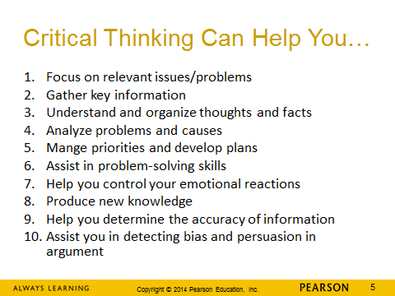

End of Unit Journal Activity: Students actually submit their responses on online course discussion page. They also must have 2 substantive peer comments.
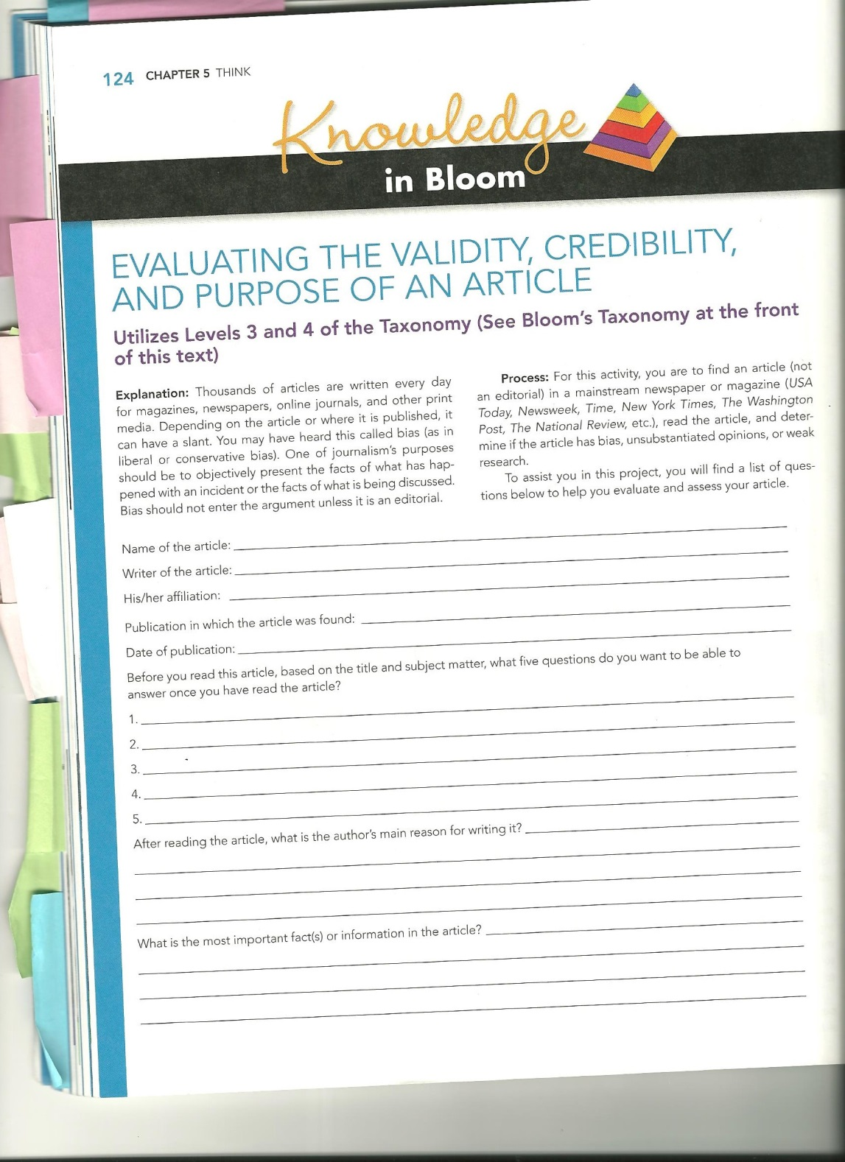

Page 2 of assignment follows:
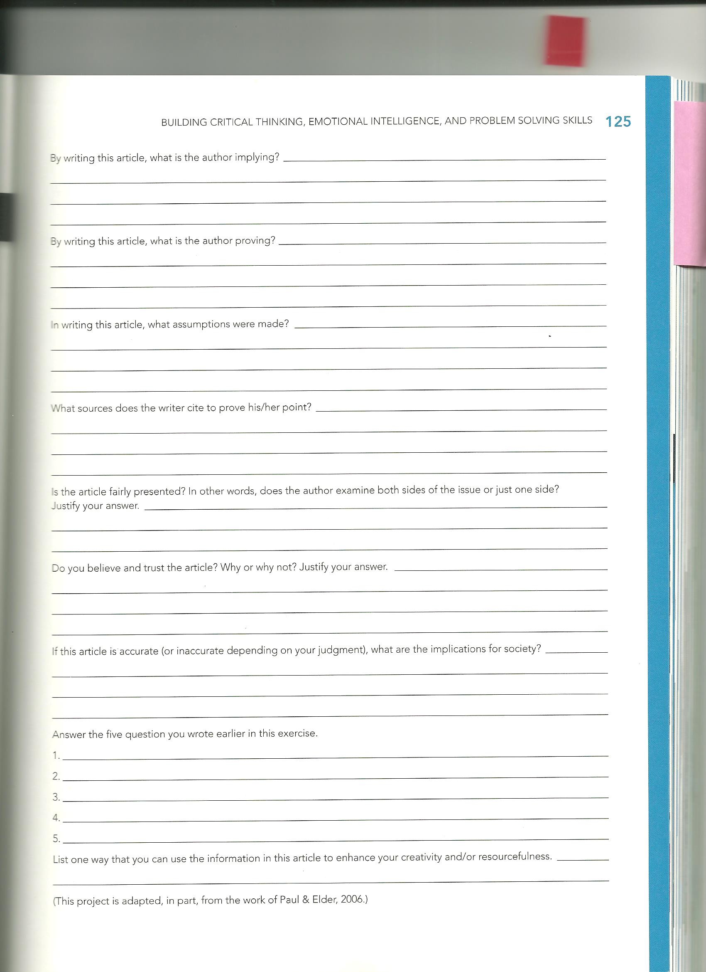
Sample student work:

Student Name Removed
2:56pm
Manage Discussion Entry
Student 1 Week 7
September 24, 2015
Are women at Indiana University safe?
Written By: Robert King and Ryan Sabalow
USA Today 5:40 p.m. EDT May 11, 2015
I chose an article about women being prone to kidnapping and murder. While reading this article a few questions came to my mind about these incidents. Why would woman not be safe? Why is this article based on only women as the victims and not men? Is the university and city police doing jobs to help prevent incidents like these? Is my own college town safe? How many cases has there been? What can we do to prevent things like this from happening?
The author wrote this article because of how many cases of women being abducted and deaths in a town 7 miles from a college town and give woman awareness of what is going on. There has been 170 cases of students from Indiana University dead since the year 2000. All deaths were a cause of murder, car crashes, overdoses, alcohol and drugs, and accidents. The town has noticed how it is drunk vulnerable white woman who are mostly getting kidnapped. Research shows that woman who are intoxicated tend to be more vulnerable and gives the perpetrator time to strike. Most cases were after woman left the bar and headed home. The author includes important facts such as how there are 1,500 deaths a year from college students by just drug and alcohol abuse. To top that are 1,000 more deaths from suicide alone.
By writing this article the author implies woman should always be very cautious of their surroundings where its from walking from class to class or walking to your car in the evenings. There are bad people all over the world and getting kidnapped or any other bad thing can happen to anyone. The author proves that incidents like this happen quite often in universities and college towns. I believe he is trying to make a point that we should spread awareness everywhere so people can take precautions to help prevent incidents like this. The author cites statistics to prove his points and to make his points more realistic.
This article is fairly presented because it not only shows statistics, it tells actual cases of woman being abducted. This article is accurate based on my judgment and implicates how woman can prevent incidents like these from happening. This article answered most of the questions I had. The universities and the city police are taking initiatives in helping keeping students safe. I believe my college town is safe as well. No matter where we go there will always be cruel people in this world and all we can do is protect ourselves and hel protect others. This article opened my eyes and makes me want to start taking better precautions while leaving work at night and walking to my car after classes. I also believe everyone should always help and look out for each other. I think this way we will help prevent bad incidents from happening.

Student 2 week 4
More than a 100 killed by Boko Haram bombings in Nigeria
By: Norimitsu Onishi
African Journalist for the New York Times
September 21, 2015
Just from the title these are my five questions. Why are people being killed? What genre of people are being targeted? Who is Boko Haram? What is being done to stop these events from happening? When did this tragedy occur?
The main reason of this article is to inform the public. To open the public's eyes to the dangers around them. Explain who the Boko Haram is and what they are doing to the public. To exploit the government for the actions the refuse to take.
There are many important facts from this article. Boko Haram is the name of a group of Islamist extremist who are currently terrorizing Nigeria. Not only are they terrorizing Nigeria they are terrorizing Chad, Niger, and Cameroon. Four explosions were detonated within 25 minutes killing more than 100 people. This occurred during a Muslim holiday week targeting specific stores and locations. Since 2009 it has been estimated 17,000 have died because of Boko Haram.
The author implies that the Boko Haram is dangerous and at fault for thousands of deaths. The author is proving more action needs to take place in order to stop the Boko Haram. If not the death toll will continue to increase. The assumptions made are that the government hasn't done their job to protect the people.
Sources used are Abba Mohammed Bashir Shuwa an aide to the Governor in a telephone interview. Col. Sani Usman the army spokesmen was used in a statement. As we as the Amnesty International in the estimation of deaths.
The author examines two side the government and the victims. However, the author left out the side of the Boko Haram. Yes I believe this article. It has a lot of facts to back it up. It also comes from a very trustworthy post. I do feel it is accurate.
In regards to the questions I asked earlier I will now answer them. First all those people were killed in a revenge attack. Second they targeted the Muslims. Third Boko Haram is an Islamist extremist group. Fourth to try to prevent any more attacks the government is trying to weaken the Boko Haram. Fifth this event occurred on Sunday the 20th of September 2015.
I learned how to ask questions before even reading the article. I have never done this before and it made me more engaged to the article. I investigated deeper into the story. As well as realized not every resource is true.

